**RAM**

When you run any application in the computer like word processor, a web browser, or a game, the computer stores the active parts of that program into RAM. The more RAM you have, the more programs you can have open at the same time without slowing your computer down. For example, 16 gigabytes (GB) of RAM means you can comfortably run several large programs at once.

Since RAM data is cleared when the power is turned off, if you are working on something and haven’t saved it to a permanent storage device (like a hard drive), you’ll lose that work if the power goes out.

**Types of RAM**

* **DRAM (Dynamic Random Access Memory):** This is the common type of RAM found in most computers.
  + DRAM stores each bit (a 1 or a 0) in a tiny component called a capacitor. It’s either charged (1) or not charged (0).
  + Many of these DRAM chips are placed on small circuit boards we call “memory sticks” or “RAM sticks.”
* **DIMM (Dual Inline Memory Module):** This refers to the form of the RAM stick that you plug into your motherboard. Different DIMMs have different numbers of pins (small metal contacts), and these must match what your motherboard supports.
  + You don’t usually buy RAM based on how many individual chips it has, but rather how much total memory it provides, like an 8 GB stick.

**Evolving RAM Technology**

* **SDRAM (Synchronous DRAM):** This type of RAM is synchronized with your system’s clock speed, which makes it faster than older forms of DRAM.
* **DDR (Double Data Rate) SDRAM:** This is a type of SDRAM that is even faster because it can transfer data twice per clock cycle. Over time, multiple versions have improved speed, reduced power consumption, and increased capacity:
  + **DDR1**
  + **DDR2**
  + **DDR3**
  + **DDR4** (the newest and fastest commonly available type)
* As DDR versions get newer, they also come with different notches and pin configurations, so you have to make sure the type of RAM you buy (like DDR3 or DDR4) matches what your motherboard supports.

**Compatibility and Motherboards**

* Just like with a CPU, you need to ensure that the RAM you buy is compatible with your motherboard.
* Motherboards have slots designed for specific types and speeds of RAM. Using the wrong type won’t work.

**The Bottom Line Summary**

* RAM is where your computer keeps the information it’s currently using.
* More and faster RAM = better multitasking and faster program performance.
* RAM clears out when the power goes off, so always save your work to permanent storage devices.
* Check your motherboard’s documentation to ensure any RAM you buy is compatible with it.

**Motherboard**

It is the central backbone of the computer. It connects all of the parts together like CPU, RAM, hard disk drives, and external devices. It allows us to add extra components like better graphics card, by plugging them into special slots.

**Key Parts of a Motherboard:**

1. **Chipset:**

The chipset in the motherboard controls how information flows between different parts of the computer. It usually contains two main parts:

* 1. **Northbridge:** Connects faster components like the CPU and RAM. In newer computers, this may be built into the CPU itself instead of being a separate chip. Other names for North bridge are host bridge and Memory Controller Hub (MCH). It controls the movement of data between the CPU and the memory of the entire system; an important enhancement in the rate of the computer. It deals with communication with high–speed graphical cards through AGP or PCIe slots; therefore, it is relevant to gaming and other graphical chores. The performance of the North Bridge determines the bus speed of the system and therefore the rate at which data can be transferred within the CPU, memory and the graphics.
  2. **Southbridge:** Connects slower devices like hard drives, USB ports, and other inputs/outputs. The main function of South bridge is to control the IO functioning. The North bridge is the medium that connects South bridge and Central Processing Unit. IO Controller Hub is the other name given to South bridge for its functionality. The South Bridge is also responsible for managing the data flow of all devices like USBs, SATA drives and audio controllers. The South Bridge is also involved in the management of some of the systems such as the power system, clock and Basic Input/ Output System.

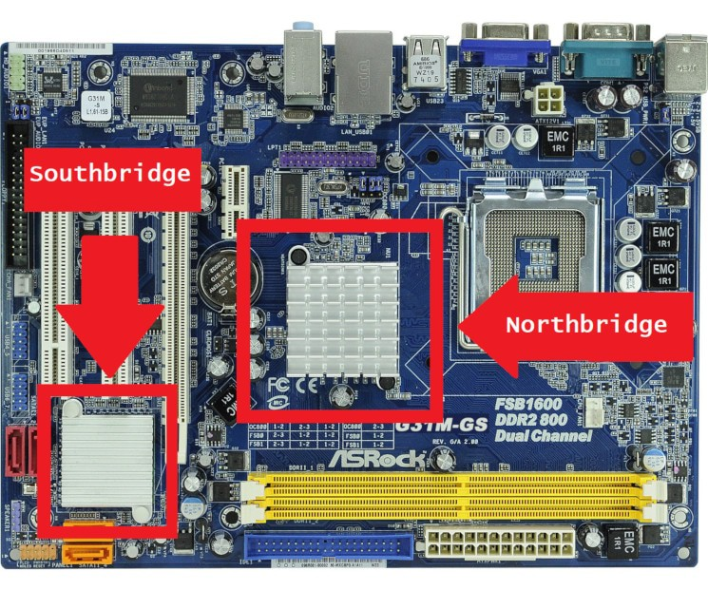

**From Youtube ICNT Gyan:**

* 1. All computer devices are connected to the motherboard with the help of sockets, slots and port/interface.
  2. Buses are responsible for data or message transfer across all parts in the computer.

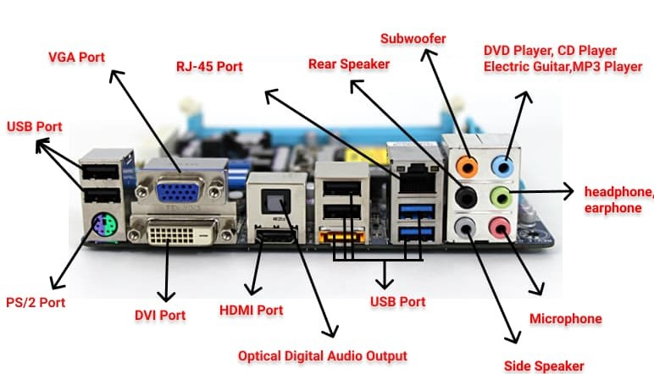

* 1. There are two types of Motherboard i.e. Plane and Mark. But these are not required now because there is only one type of motherboard used in the market.
  2. Some companies of motherboards are:
     + Intel (It stopped making motherboards)
     + Gigabyte (best motherboards right now in the market)
     + Ashrock
     + Asus
     + MSI
     + Biostar
  3. There are two segments of motherboards before. They are:
     + Integrated Motherboard: Comes with all parts integrated with it. Like every other parts like ports, sockets are built in with it.
     + Non-integrated Motherboard: We must add external parts per our requirements.

These do not need to be learned in depth because we have all the integrated motherboards nowadays.

* 1. Major Brands:
     + Desktop Motherboards:   
       Used in Desktop systems. It is easy to upgrade motherboard in desktops because it is very cheap comparing to other motherboards and also because motherboards in desktop is larger right which makes it easier to replace as well.
     + Laptop Motherboards:

It is used in Laptop. Since all components are placed inside the limited space, it is very difficult to change the motherboard in laptops. That’s why it is rare to upgrade motherboards in laptops.

* + - Server Motherboards:

It is used in Server. Bigger in size having many ports and designed for high-end works.

**History of Motherboards:**

1. AT: Oldest form (12 pins)
2. ATX: Second one (20pins)
3. BTX: Used nowadays everywhere (24 pins in power supply)
   1. Everything is connected in the computer through sockets, slots and ports. Like Network Interfaces, CPU and motherboards are connected through sockets, RAM are connected through slots and external devices are connected to Ports.
   2. Non-volatile BIOS memory refers to a small memory on PC motherboards that stores BIOS Settings.

**Expansion Slots:**

Three types: ISA (Industry Standard Architecture) Slots, PCI (Peripheral Component Interconnect Bus) Slots and AGP(Accelerates Graphics Port) Slots.

We do have options in our motherboard whether we want to add external cards or not to improve our system functionality or may be some of the ports of our computer ports are damaged like network ports, then we can add new ports through the expansion slots.

Basically, if we need to add extra ports or anythings like graphics cards or any other things, we do it through the expansion slots.

Nowadays, we have the PCI slots only.

Accelerates Graphics Ports:

It is a high speed point to point channel for attaching a video card to a computer’s motherboard. The primary advantage of AGP over PCI is that it provides a dedicated pathway between the slot and the processor rather than sharing the PCI bus.

Peripheral Component Interconnect Bus:

It is a local bus system which is independent of processor bus speed. The PCI architecture incorporates its own chip set which link the local bus to the main bus which are called bridges which are “South Bridge” and “North Bridge”.

**Chipset In motherboards:**

An electronic component that manages the flows of entire data in the entire system like from CPU, motherboard, peripherals, etc.

It contains two bridge that is South Bridge and North Bridge.

As we see in the figure, the northbridge connects faster components like RAM, CPU and AGP cards, whereas the southbridge connects peripheral devices that have slower capabilities compared to the RAMs, CPU and AGP.

Remember, NorthBridge is always built very close to Microprocessor.